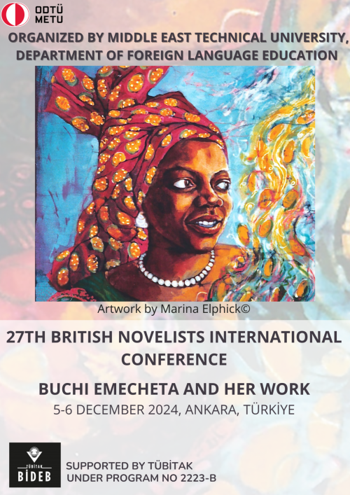

**CONFERENCE PROGRAM**

**27TH METU BRITISH NOVELISTS INTERNATIONAL CONFERENCE:**

**“BUCHI EMECHETA AND HER WORK”**

**5-6 DECEMBER 2024**

**METU CULTURE AND CONVENTION CENTER**

**MIDDLE EAST TECHNICAL UNIVERSITY, ANKARA, TÜRKİYE**

**DAY I:**

**5 DECEMBER 2024, THURSDAY**

**09.30 – 10.00:** REGISTRATION

**10.00 – 10.20:** OPENING REMARKS – HALL D

**Prof. Dr. Nurten Birlik,** Head of the Department of Foreign Language Education

**10.20 – 11.20:** KEYNOTE SPEECH

Chair: Prof. Dr. Burçin Erol

**Prof. Dr. Alena Rettová, University of Bayreuth**

“Thinking Newly: Buchi Emecheta on Gender, Migration, and Innovation”

**11.20 – 11.40:** COFFEE BREAK

|  |
| --- |
| Chair: Prof. Dr. Deniz Bozer  **Assoc. Prof. Dr. Ömer Öğünç,** Aksaray University  “Racial and Personal Borders in Buchi Emecheta’s  *Kehinde*: Immigration and Identity Crisis”  **Asst. Prof. Dr. Fahime Serhatti,** Yuksek Ihtisas University  “Beyond ‘Third Space’: Decolonial Hope in  Buchi Emecheta’s *Second Class Citizen*”  **Merve Peköz,** Ordu University  “Cultural Hybridization in Buchi Emecheta’s *The Rape of Shavi*” |

**11.40 – 12.40: SESSION I – HALL D**

**12.45 – 14.00:** LUNCH BREAK

**14.15 – 15.30: SESSION II**

|  |  |
| --- | --- |
| **HALL D** | **HALL B** |
| Chair: Prof. Dr. Huriye Reis  **Assoc. Prof. Dr. Ela İpek Gündüz**, Gaziantep University  “Buchi Emecheta: at Threshold Yet Survived”  **Aybüke Güzen-Çiftçi**, Ordu University  “Motherhood: Burdening or Empowering? A Matricentric Feminist Analysis of Buchi Emecheta’s *The Second Class Citizen*”  **Asst. Prof. Dr. Nağme Nayebpour**, Agri İbrahim Cecen University  “The Construction of Motherhood in Buchi Emecheta’s *The New Tribe*” | Chair: Assoc. Prof. Dr. Margaret J.M. Sönmez  **Güvenç Arman Arı**, TED University  “The Griot’s Song: Tracing Back African Oral Traditions in *The Slave Girl*”  **Dr. Adesanya M. Alabi**, Ostim Technical University  “Gender Roles and Social Customs in African Literature: An Expression of Anachronistic Culture in Buchi Emecheta’s *The Bride Price*”  **Zeynep Türkü Ekşi**, Yeditepe University  “Women as Commodities: An Analytical Reading of Emecheta’s *The Bride Price* in Relation to Irigaray’s ‘Women on the Market’” |

**15.30 – 15.45:** COFFEE BREAK

|  |
| --- |
| Chair: Assoc. Prof. Dr. Yavuz Çelik  **Asst. Prof. Dr. Elzem Nazli,** Batman University  “Narrative Empathy through Ambivalence: A Dual Lens on Narrative  Complexity and Emotional Depth in *The Rape of Shavi*”  **Asst. Prof. Dr. Şevket Sarper Dörter,** Istanbul Aydin University  “Alienation in Time: Navigating Patriarchal Temporalities in  *The Joys of Motherhood*”  **Asst. Prof. Dr. Yağmur Sönmez-Demir,** Cankaya University  “Evocation of Readers’ Sympathy in Emecheta’s *Gwendolen*” |

**15.45 – 17.00: SESSION III – HALL D**

**DAY II:**

**6 DECEMBER 2024, FRIDAY**

**10.00 – 11.15: SESSION I – HALL D**

|  |
| --- |
| Chair: Prof. Dr. Nazan Tutaş  **Prof. Dr. Burçin Erol**, Hacettepe University  “Buchi Emecheta’s *The New Tribe*: Constructing New Identities”  **Assoc. Prof. Dr. Abdullah Nejat Töngür**, Maltepe University  “Quest for Self-fulfilment in ‘a man’s world’: *Kehinde* by Buchi Emecheta”  **Assoc. Prof. Dr. İsmail Avcu &**  **Hilâl Yantur**, Ataturk University  “Intersectionality of Gender and Colonialism in  Buchi Emecheta’s *The Joys of Motherhood*” |

**11.15 – 11.30:** COFFEE BREAK

**11.30 – 12.45: SESSION II**

|  |  |
| --- | --- |
| **HALL D** | **HALL B** |
| Chair: Asst. Prof. Dr. Timothy Wright  **Asst. Prof. Dr. Ayşegül Turan,** Istanbul Kultur University  “Lodgings, Hospital Wards, Libraries: Spaces of Belonging and Non-Belonging in Buchi Emecheta’s *Second Class Citizen*”  **Leman Demirbaş,** Gazi University  “Navigating Urban Landscapes: Female Subjectivity and Identity Formation in Buchi Emecheta’s *Second-Class Citizen*” | Chair: Asst. Prof. Dr. Selen Aktari Sevgi  **Cem Berkay Eminoğlu**, Koc University  “Nomadic Subjectivity and Writing as a Site of Nomadic Existence in Buchi Emecheta’s *Second-Class Citizen*”  **Yusuf Aybars Elçi**, Middle East Technical University  “The Impact of ‘Otherness’ in Buchi Emecheta’s *In The Ditch*: A Post-colonial Reading”  **Rüveyda Büyüktelli**, Atilim University  “Buchi, Florence, Adah: The Mythification of the  Self and Postcolonial Autobiography Writing in Emecheta’s *Head Above Water*” |

**13.00 – 14.00:** LUNCH BREAK

**14.15 – 15.10: SESSION III – HALL D**

|  |
| --- |
| Chair: Prof. Dr. Özlem Uzundemir  **Asst. Prof. Dr. Nesrin Koç,** Mudanya University  “Joys of Authorship: Buchi Emecheta’s Construction of  Her Authorial Identity in *Head Above Water*”  **Asst. Prof. Dr. Gökhan Albayrak**, Ankara University  “The Cutting of the Umbilical Cord: Gynocentric Metaphors and  Affective Constellations in Buchi Emecheta’s *Gwendolen*’’  **Beyza Betül Tanrıkulu,** Adana Alparslan Türkeş Science and Technology University  “Buchi Emecheta’s *Kehinde*: Exploring the Canvas Ceiling and Feminist Themes” |

**15.10 – 15.30:** COFFEE BREAK

**15.30 – 15.45:** **CLOSING REMARKS – HALL D**

**VOTING RESULTS FOR THE THEME OF THE NEXT CONFERENCE**